Popped Wild Rice

As we near the end of the Wild Rice season in Northern Minnesota, we are excited about all the incredible dishes we can make with fresh harvested wild rice! The Wild Rice House/Manoomin Waakaa’igan/Villirisi Talo in Finland, MN is a new processing facility operated by the Finland Food Chain that aims to make wild rice harvesting and processing more accessible for residents of the Arrowhead region. With a large and small parcher, winnower, thresher, and gravity table, our processing facility has the equipment and expertise to help make the most of your harvest! Visit finlandwildrice.com or call our processor, Blake, at 612-298-8561 for specific processing operation questions and availability. Here’s a recipe that is perfect for freshly harvested and processed wild rice to add some texture or garnish to salads, sides, or even a bowl of ice cream with maple syrup! The freshly processed wild rice still has just enough moisture to pop the grains just like popcorn kernels.

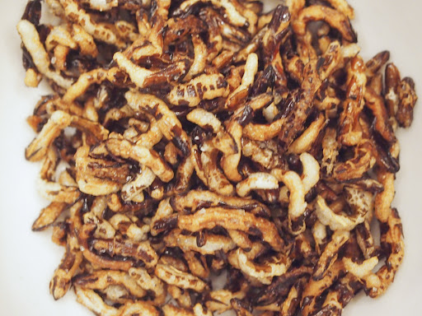
Ingredients:

1/2 cup Wild Rice (freshly processed works best here)
1/4 cup Oil for frying (vegetable, canola, avocado, etc.)
Salt to taste

Steps:
- In a small saucepan with a lid, add ¼ cup of oil, or just enough to cover the bottom of the pan in a thin layer. Turn heat to high and add 2-3 grains of wild rice.
- When the grains of wild rice in the pan pop, add the ½ cup of wild rice and gently shake the pan to cover each grain of wild rice in oil. Keep gently shaking the pot over the heat source to keep the grains moving.
- When the grains start to pop, cover the pan with the lid and keep gently shaking until the popping slows to 2-3 seconds between pops.
- Pour out popped grains onto a plate with a paper towel to drain the oil. Season with salt immediately.
- Once cooled, popped wild rice and be stored at room temperature in a covered container for up to 1 week. Add popped grains for some crunch in a salad, atop creamy soups, or even in a sundae with vanilla ice cream and local Maple Syrup!

Tips:
- For even puffier grains of wild rice, preheat a quart of oil in a large pot to deep-fry. Pour a few tablespoons of wild rice at a time into a small sieve/strainer with a handle and lower into the hot oil. Shake the strainer until the wild rice pops. These grains will look like puffed rice cereal!
- Be sure to season popped wild rice within 10-15 seconds of removing from oil. Once the oil is drained and dried, the salt won’t stick.

